YEAR 2 HOME LEARNING
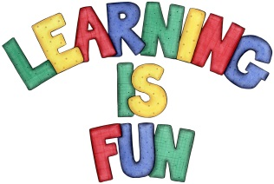
Date Set | 14.12.18
Date Due | 19.12.18
Mathletics | On Matheletics focus on addition and subtraction, multiples of 2, 5 and 10, fractions and finding ½, ¼ and ¾ of shapes. Additionally, focus on finding ½ and ¼ of numbers from the multiples of the 2 and 4 times tables and on money. All activities can be found on matheletics.com. Every child has their username and passwords in their reading records.
Spellodrome  Writing | Your Homework challenge this week is to research and investigate how Christmas is celebrated around the world. You can choose any country that you would like to research. You might want to include:  - What do people do to celebrate Christmas?  - Do they have any special traditions that they participate in?  - Where do they go and why?  - Are there any special foods that they might eat?  - You could also include any other interesting information that you find.  This week please review the spellings that you have learnt this term and make sure that you are confident in these.
Reading | Recommended daily reading time:  KS1 20 minutes.
Home Learning Project | Date Set: N/A Date Due:
Greek | Please go to Greek Class Blog for Greek Home Learning  Greek Class - St Cyprian's Greek Orthodox Primary Academy

