YEAR 2 HOME LEARNING
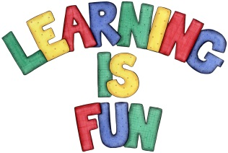
Date Set | 21.12.18
Date Due | 9.1.19
Mathletics | On Matheletics focus on addition and subtraction, multiples of 2, 5 and 10, fractions and finding ½, ¼ and ¾ of shapes. Additionally, focus on finding ½ and ¼ of numbers from the multiples of the 2 and 4 times tables and on money. If children are confident in the 2, 5 and 10 times tables please start learning the 3, 4 and 6 times tables. All activities can be found on matheletics.com. Every child has their username and passwords in their reading records.
Spellodrome  Writing | Your Homework challenge over the holidays is to research your favourite sports person. It could be a footballer, swimmer, gymnast etc (you can decide) and write a short biography about them.  Your home learning project for over the holidays is to create a booklet or a leaflet about what do humans need to stay healthy? In your booklet you could include:  - What is a healthy diet?  - Why is exercise important for our bodies?  - What is personal hygiene and how do we keep our bodies healthy?  - Why do we need to look after our teeth?  Spellings to learn this week  - wild  - child  - floor  - door  - grass  - class
Reading | Recommended daily reading time:  KS1 20 minutes.
Home Learning Project | Date Set: 21.12.18 A booklet or leaflet about what do humans need to stay healthy? Date Due: 9.1.19
Greek | Please go to Greek Class Blog for Greek Home Learning  Greek Class - St Cyprian's Greek Orthodox Primary Academy

