YEAR 3 HOME LEARNING
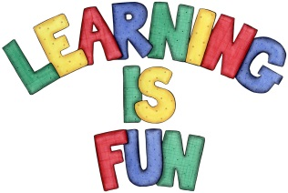
Date Set | 18/01/19
Date Due | 23/01/19
Mathletics | This week will be learning how to tell the time on an analogue clock and working out addition and subtraction word problems.
Spellodrome  Writing | This week’s spellings:  - Information  - Preparation  - Admiration  - Sensation  - Determination  - Publication  - Multiplication  - Operation  - Mention  - Position  Spellings can also be found on spellodrome.com if you would like extra practice.  Writing Task  Zakynthos:  This week for your home learning, I would like you to write a recount of our trip to the Hornimans museum. You must write at least one page. Think about: how did you there? What did you do? What did you see? Did you learn anything new?  This homework is due Wednesday 23rd January 2019.  Spetses:  This week for your home learning, I would like you to write a book review of George’s Marvellous Medicine. What did you like about the story? Would you recommend it to a friend? What would you give the book out of ten and why? I would like at least one page of writing. This home learning is due Wednesday 23rd January 2019.
Reading | Recommended daily reading time:  KS2 40 minutes.
Home Learning Project | Date Set: n/a Date Due: n/a
Greek | Please go to Greek Class Blog for Greek Home Learning  Greek Class - St Cyprian's Greek Orthodox Primary Academy

