YEAR 3 HOME LEARNING
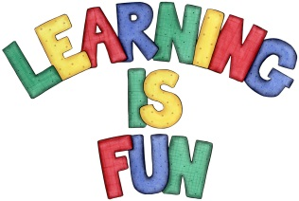
Date Set | 25/01/19
Date Due | 30/01/19
Mathletics | This week we will be learning how to tell the time on an analogue clock using roman numerals and learning about horizontal, vertical and perpendicular lines. Extra practice will be on Mathletics.
Spellodrome  Writing | This week’s spellings:  - Autograph  - Automobile  - Automatic  - Subtitle  - Supermarket  - Superman  - antifreeze  - antisocial  - subheading  - autobiography  Spellings can also be found on spellodrome.com if you would like extra practice.  Writing Task  Spetses:  This week for your home learning, I would like you to write a recount of our trip to the Hornimans museum. You must write at least one page. Think about: how did you there? What did you do? What did you see? Did you learn anything new?  This homework is due Wednesday 23rd January 2019.  Zakynthos:  This week for your home learning, I would like you to write a book review of George’s Marvellous Medicine. What did you like about the story? Would you recommend it to a friend? What would you give the book out of ten and why? I would like at least one page of writing. This home learning is due Wednesday 23rd January 2019.
Reading | Recommended daily reading time:  KS2 40 minutes.
Home Learning Project | Date Set: n/a Date Due: n/a
Greek | Please go to Greek Class Blog for Greek Home Learning  Greek Class - St Cyprian's Greek Orthodox Primary Academy

