KS2 Writing competition: Black History Month, October 2015

Celebrating athletes of African descent who have made a significant impact in the history of sport
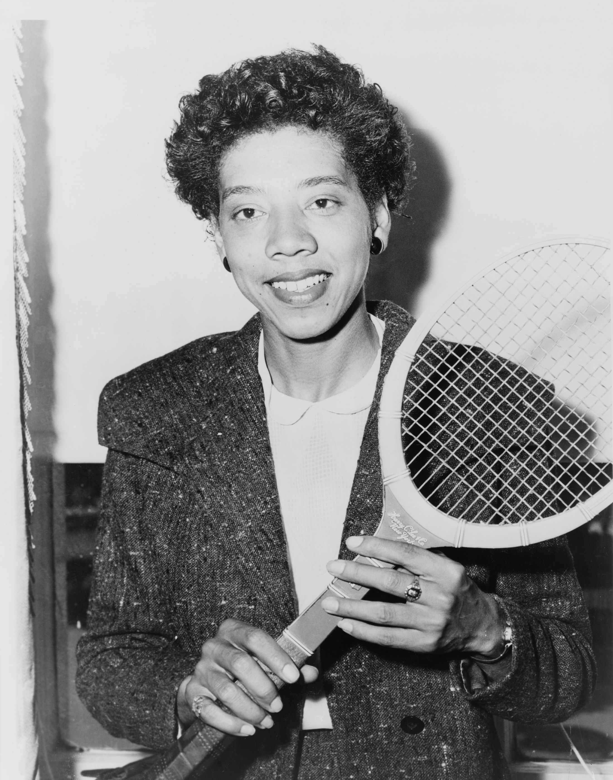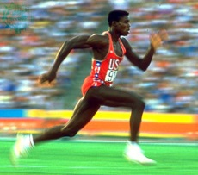
Our challenge is for Key Stage 2 children in Croydon schools to use their creative writing skills to write a poem celebrating an athlete of African descent who has made a significant impact in the history of sport.
Ideally the poem should reflect details of their chosen sports person and a memorable event that this athlete was involved in.
Criteria:
Choose one of these athletes of African descent:
- Arthur Ashe
- Althea Gibson
- Muhamad Ali
- Jesse Owen
- Carl Lewis
- Joe Lewis
- Wilma Rudolph
- Gabby Douglas
- Daley Thompson.
Entries must be an A4 design (either landscape or portrait).
The poem can be up to 30 lines and can be either hand written, or produced on a computer.
Prizes:
The winner will be presented with a prize of writing supplies as well as having their poem published on our website.
There will also be runner up and third place prizes as well as highly commended certificates.
Entry:
Please send all entries to Julien Muana Lubo, Croydon School Sport Partnerships, St. Peter’s Primary School, Normanton Road, South Croydon, Surrey, CR2 7AR or
Croydonssp@st-peters.croydon.sch.uk
On the reverse of the competition entry, please include your name, your school’s name and your school year (as at September 2015).
Closing date for Friday 2nd October 2015.

