YEAR 4 HOME LEARNING
Date Set | Friday 23rd October
Date Due | Friday 6th November
Mathletics | 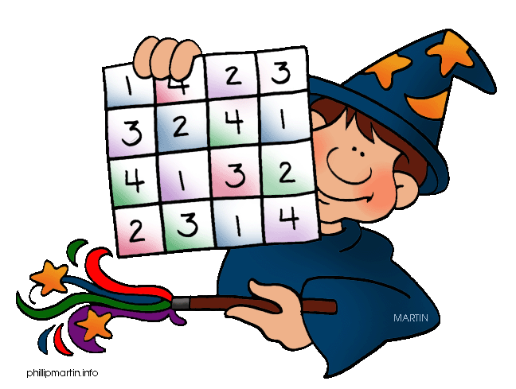  Children should complete all assigned activities. Children will also be given an assessment to complete online.
Spellodrome | This set of spellings focuses on words with ‘sc’  science  scene  scent  scissors  muscle  discipline  fascinate  obscene  scenery  descent  scenic  ascend  ascent  fascinating  scientific  pioneers  quadruple  exposition  nutrition  stethoscope
Reading | Recommended daily reading time:  KS2 40 minutes  Children should record what they have read in their reading records.
Home Learning Project | Date Set: 23rd October Date Due: 13th November  Children should research and write a report on the Romans. Children can choose any aspect of the topic and can be as creative as they like!
Greek | Please go to Greek Class Blog for Greek Home Learning  Greek Class - St Cyprian's Greek Orthodox Primary Academy

