YEAR 2 HOME LEARNING
Date Set | Friday 23rd October 2015
Date Due | Friday 6th November 2015
Mathletics | 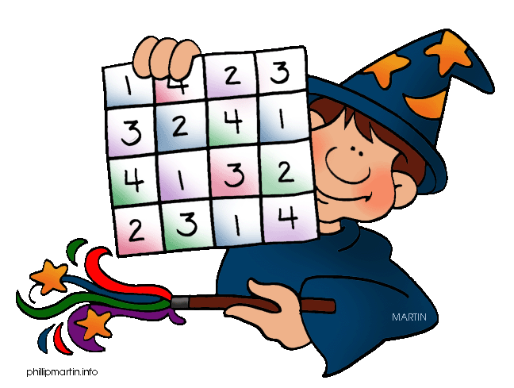  We would like the children to complete the tally and picture graph activities on their Mathletics profile. For example they will be given a number of objects and they have to check if the tally has been completed correctly. They will also be given different picture graphs and have to answer questions on them.
Spellodrome  Writing | We would like the children to learn words that begin with ‘wr’  such as written, wrote, wrong etc.  The children will also be  completing an activity where they need to identify the  correctly punctuated sentence.
Reading | Recommended daily reading time:  KS1 15-20 minutes  KS2 40 minutes
Greek | Please go to Greek Class Blog for Greek Home Learning  Greek Class - St Cyprian's Greek Orthodox Primary Academy

