YEAR 6 HOME LEARNING
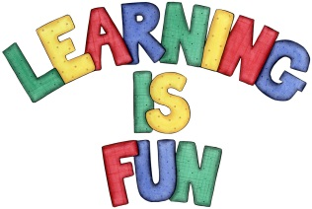
Date Set | 13/11/15
Date Due | Pink Book Writing Task: Wednesday 18th November  Mathletics and Spellings: Friday 20th November
Mathletics | There are two new assignments:  1: Multiplying mentally  2: Estimating multiplication and division for calculating mentally
Spellodrome  Writing | Your spellings are:  doubt, island, lamb, solemn, thistle, knight , guard, guest, guardian,  guide, plumber, comb, tomb, thumb, calm, calf, chalk, hymn, column, rhyme, ghost, debt, sword, wreck  Your writing task this week is to write a persuasive letter to your parents. It can be about anything you want, but you must try to persuade them to agree to something / allow you to do something / agree with you about something.
Reading | 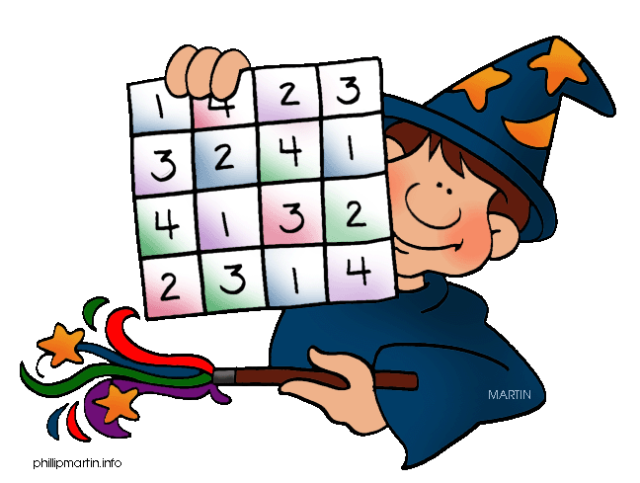  Recommended daily reading time:  KS1 15-20 minutes  KS2 40 minutes
Home Learning Project | Date Set: Friday 13th November  Date Due: Pink Book Writing Task: Wednesday 18th November  Mathletics and Spellings: Friday 20th November
Greek | Please go to Greek Class Blog for Greek Home Learning  Greek Class - St Cyprian's Greek Orthodox Primary Academy

