YEAR 6 HOME LEARNING
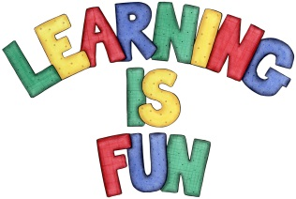
Date Set | 20/11/15
Date Due | Pink Book Writing Task: Wednesday 25th November  Mathletics and Spellings: Friday 27th November
Mathletics | You have been assigned some tasks relating to the methods we have been using for mental calculations this week. There are three new activities on mental multiplication and division.
Spellodrome  Writing | Will be confirmed on Monday 22nd Nov  Your writing task this week is to imagine you were a child living in London during World War 2 and you are evacuated to the country. Write a story about what happened to you.  You should spend 15 minutes planning and 45 minutes writing.
Reading | 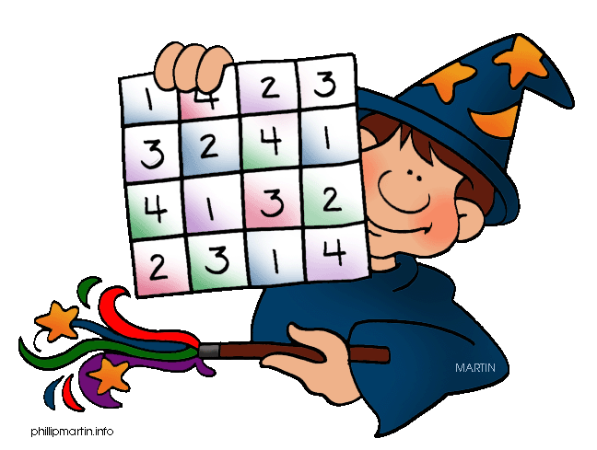  Recommended daily reading time:  KS1 15-20 minutes  KS2 40 minutes
Home Learning Project | Date Set: Friday 20th November  Date Due: Pink Book Writing Task: Wednesday 25th November  Mathletics and Spellings: Friday 27th November
Greek | Please go to Greek Class Blog for Greek Home Learning  Greek Class - St Cyprian's Greek Orthodox Primary Academy

