YEAR 6 HOME LEARNING
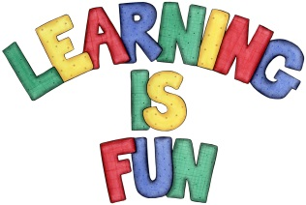
Date Set | 27/11/15
Date Due | Pink Book Writing Task: Wednesday 2nd December  Mathletics and Spellings: Friday 5th December
Mathletics | You have been assigned some tasks relating to activites we have done. There are activities relating to units of measure including litres and millilitres, units of length and units of mass.  There are also two activities relating to area and perimeter.
Spellodrome  Writing | ought, bought, thought, nought, brought, fought  rough, tough, enough cough though, although, dough  through thorough, borough plough, bough  This week we have been writing poems on animals in captivity. For your writing task this week you are to write a poem about something you are passionate about. It is up to you what topic you choose. Remember to include rhyme, similes, metaphors, alliteration etc.
Reading | 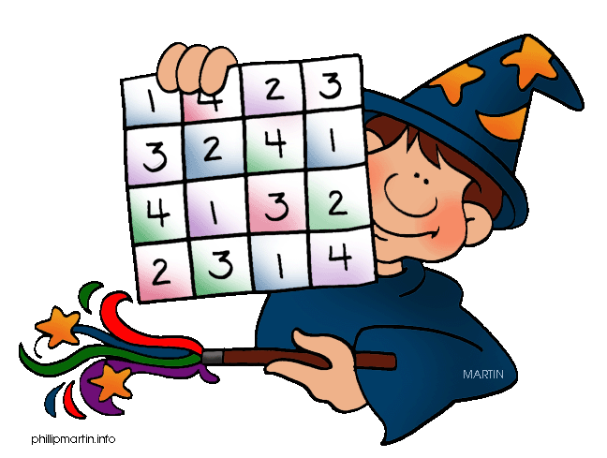  Recommended daily reading time:  KS1 15-20 minutes  KS2 40 minutes
Home Learning Project | Date Set: Friday 27th November  Date Due: Pink Book Writing Task: Wednesday 2nd December  Mathletics and Spellings: Friday 5th December
Greek | Please go to Greek Class Blog for Greek Home Learning  Greek Class - St Cyprian's Greek Orthodox Primary Academy

