YEAR 6 HOME LEARNING
Date Set | 6/11/15
Date Due | Pink Book Writing Task: Wednesday 11th November  Mathletics and Spellings: Friday 13th November
Mathletics | There are two new assignments:  1: Complete a task solving long multiplication questions. For further help with this see:  https://www.mathsisfun.com/numbers/multiplication-long.html  1: Complete a task solving long division questions. For further help with this see: http://www.mathsonline.org/pages/longdiv.html
Spellodrome  Writing | Your spellings are:  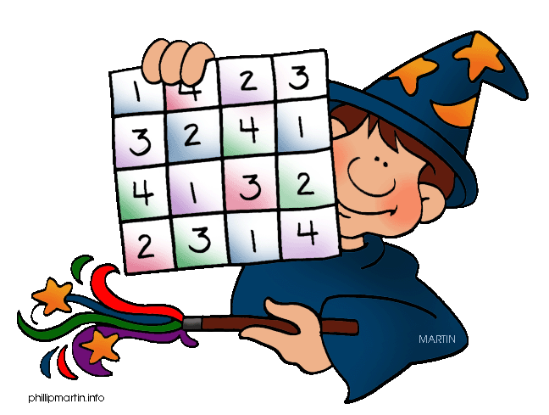  ceiling receive receipt deceit perceive conceit  vein rein reign veil weigh freight  eight neighbour sovereign foreign  weird protein their either neither height heir  Write a balanced discussion on the topic:  Should children be allowed mobile phones in school?
Reading | Recommended daily reading time:  KS1 15-20 minutes  KS2 40 minutes
Home Learning Project | Date Set: Friday 6th November  Date Due: Pink Book Writing Task: Wednesday 11th November  Mathletics and Spellings: Friday 13th November
Greek | Please go to Greek Class Blog for Greek Home Learning  Greek Class - St Cyprian's Greek Orthodox Primary Academy

