YEAR 4 HOME LEARNING
Date Set | Friday 6th November
Date Due | Friday 13th November
Mathletics | 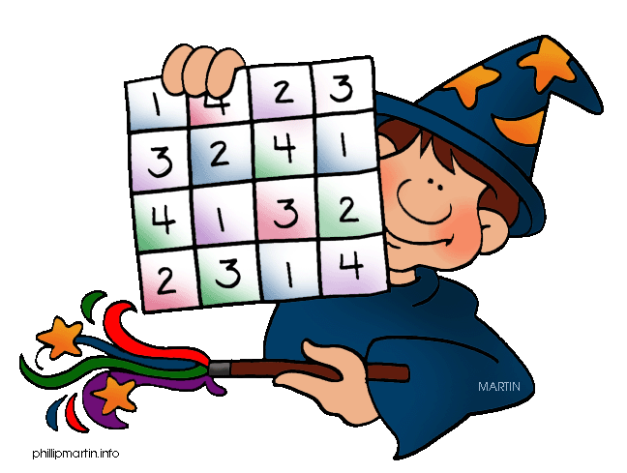  Children should complete all assigned activities. Children will also be given an assessment to complete online.
Spellodrome | This set of spellings focuses on words with the suffix ‘ly’  usually  gently  simply  assembly  bubbly  crumbly  probably  nobly  who  whirl  spaghetti  rhythmic  rhinoceros  ghastly  heir  rhubarb  shepherd  language  interpret  straighten
Reading | Recommended daily reading time:  KS2 40 minutes  Children should record what they have read in their reading records.
Home Learning Project | Date Set: 23rd October Date Due: 13th November  Children should research and write a report on the Romans. Children can choose any aspect of the topic and can be as creative as they like!
Greek | Please go to Greek Class Blog for Greek Home Learning  Greek Class - St Cyprian's Greek Orthodox Primary Academy

