YEAR 1 HOME LEARNING
Date Set | 27.11.2015
Date Due | 4.12.2015
Mathletics | 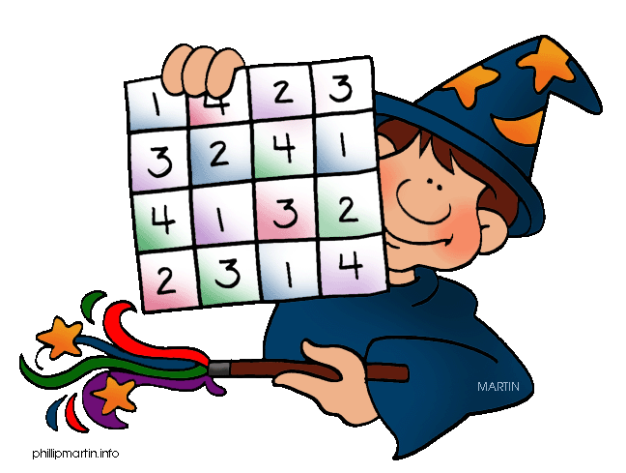  Addition and Subtraction  Activities: Addition Facts
Spellodrome  Writing | List 4  Practice 5 words from list 4 in cursive handwriting (you do not need to bring this into school)
Reading | Recommended daily reading time:  Year 1 15-20 minutes
Home Learning Project | Date Set: 6.11.2015 Date Due: 7.12.2015  Make a poster about the four seasons. Show the changes in the seasons and create pictures to show the changes. How does the weather change in each season? What clothes do you wear in each season? How do animals and plants change? What can you see and hear? Where do the leaves go in winter? You could add photographs, draw pictures and record information about interesting facts.
Greek | Please go to Greek Class Blog for Greek Home Learning  Greek Class - St Cyprian's Greek Orthodox Primary Academy

