YEAR 2 HOME LEARNING
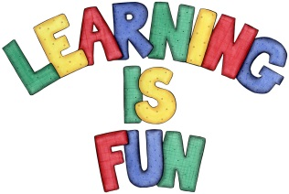
Date Set | Friday 13th November 2015
Date Due | Friday 20th November 2015
Mathletics | 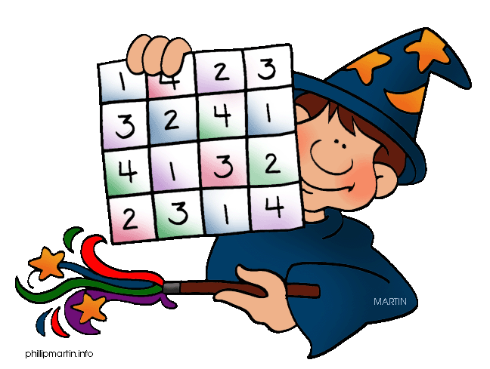  We would like the children to complete the simple subtraction and symmetry activities on their Mathletics profile. For example they will be given a variety of simple subtraction that they need to solve. They will also be given different objects and they have to identify which ones are symmetrical.
Spellodrome  Writing | We would like the children to learn words that end with ‘el’  such as tinsel, towel, camel, tunnel etc.  The children will also be  completing an activity where they need to identify the  sentence/s where the full stops are in the correct places.
Reading | Recommended daily reading time:  KS1 15-20 minutes  KS2 40 minutes
Greek | Please go to Greek Class Blog for Greek Home Learning  Greek Class - St Cyprian's Greek Orthodox Primary Academy

