YEAR 2 HOME LEARNING
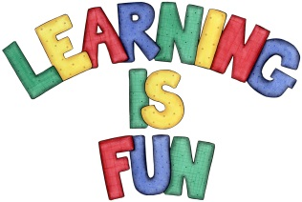
Date Set | Friday 20th November 2015
Date Due | Friday 27th November 2015
Mathletics | 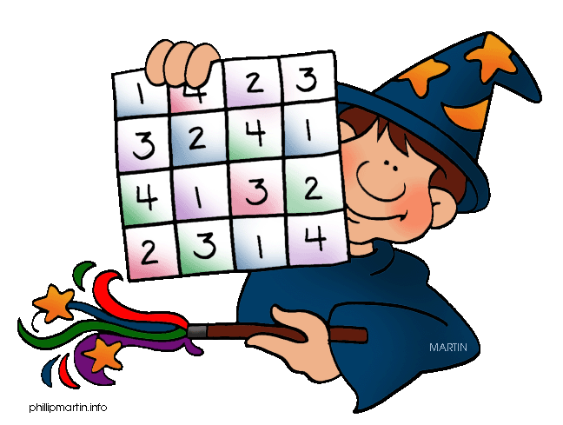  We would like the children to complete the doubles and halves and how heavy? Activities on their Mathletics profile. For example they will be given have to work out either the double half of numbers given to them up to 20. They will also be given different objects that they have to weigh and record the weight.
Spellodrome  Writing | We would like the children to learn words that end with ‘al’  such as metal, pedal, capital, hospital, animal etc.  The children will also be  completing an activity where they need to identify the  correct nouns to complete a variety of sentences.
Reading | Recommended daily reading time:  KS1 15-20 minutes  KS2 40 minutes
Greek | Please go to Greek Class Blog for Greek Home Learning  Greek Class - St Cyprian's Greek Orthodox Primary Academy

