YEAR 2 HOME LEARNING
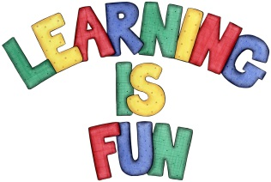
Date Set | Friday 27th November 2015
Date Due | Friday 4th December 2015
Mathletics | 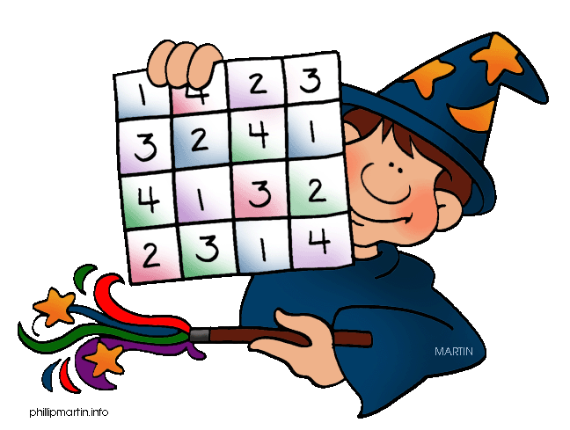  We would like the children to complete the groups of 10 and how full? activities on their Mathletics profile. For example they will be given groups of 10 from which they need to work out how many groups there are and what the total is e.g. 7 groups of 10 = 70. They will also be given different objects that they have to identify how full they are using the language of full, over half full, half full, less than half and empty.
Spellodrome  Writing | We would like the children to learn words that end with ‘il’  such as fossil, pencil, nostril, until etc.  The children will also be  completing an activity where they need to identify the  correct adjectives to complete a variety of sentences.
Reading | Recommended daily reading time:  KS1 15-20 minutes  KS2 40 minutes
Greek | Please go to Greek Class Blog for Greek Home Learning  Greek Class - St Cyprian's Greek Orthodox Primary Academy

