YEAR 2 HOME LEARNING
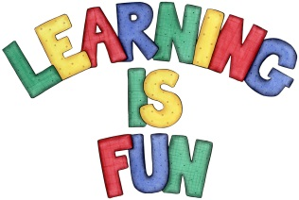
Date Set | Friday 6th November 2015
Date Due | Friday 13th November 2015
Mathletics | 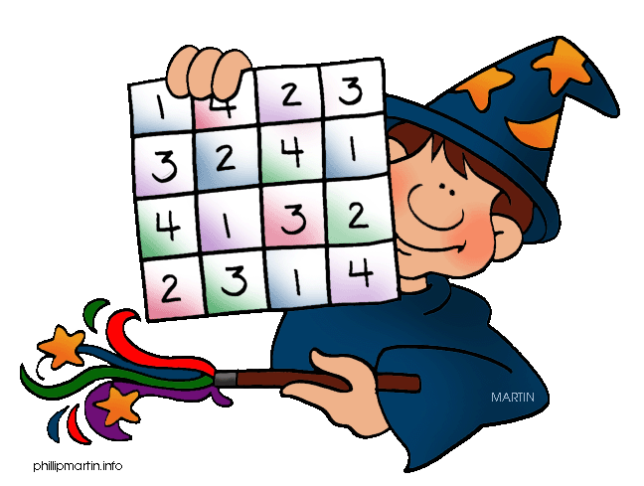  We would like the children to complete the direction and left or right activities on their Mathletics profile. For example they will be given a set of directions that they will have to follow and identify where they finish. They will also be given different objects that they have to place either left or right of a different object.
Spellodrome  Writing | We would like the children to learn words that end with ‘le’  such as little, middle, bottle, apple etc.  The children will also be  completing an activity where they need to identify the  sentence/s where the full stops are in the correct places.
Reading | Recommended daily reading time:  KS1 15-20 minutes  KS2 40 minutes
Greek | Please go to Greek Class Blog for Greek Home Learning  Greek Class - St Cyprian's Greek Orthodox Primary Academy

