YEAR 6 HOME LEARNING
Date Set | 4/12/15
Date Due | Pink Book Writing Task: Wednes1day 9th December  Mathletics and Spellings: Friday 11th December
Mathletics | You have been assigned some tasks relating to activities we have done about shape and measure in class.  All previous activities have been removed. Please make sure you complete these one by Friday.
Spellodrome  Writing | accommodate accompany according achieve aggressive amateur ancient apparent appreciate attached available average awkward  bargain bruise category cemetery committee communicate community  Your writing task this week is to write a letter of complaint. You are to imagine you went to a theme park with your family and everything went wrong! Your favourite ride was closed when you got there, someone threw up on you on the roller coaster, it rained, there were long queues and you didn’t like your burger and chips.
Reading | 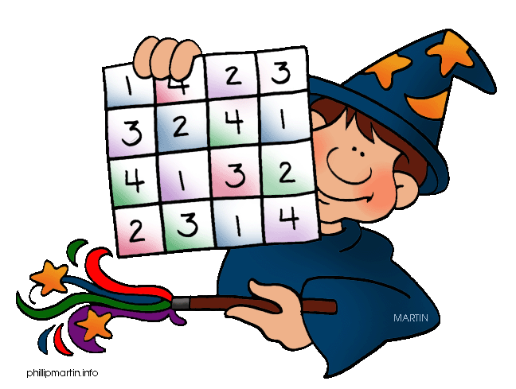  Recommended daily reading time:  KS1 15-20 minutes  KS2 40 minutes
Home Learning Project | Date Set: Friday 11th November  Date Due: Pink Book Writing Task: Wednesday 9th December  Mathletics and Spellings: Friday 11th December
Greek | Please go to Greek Class Blog for Greek Home Learning  Greek Class - St Cyprian's Greek Orthodox Primary Academy

