YEAR 1 HOME LEARNING
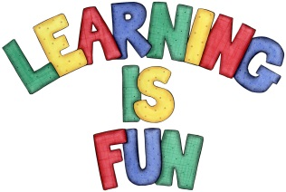
Date Set | 11.12.2015
Date Due | 18.12.2015
Mathletics | Click on Number and Place Value to 50  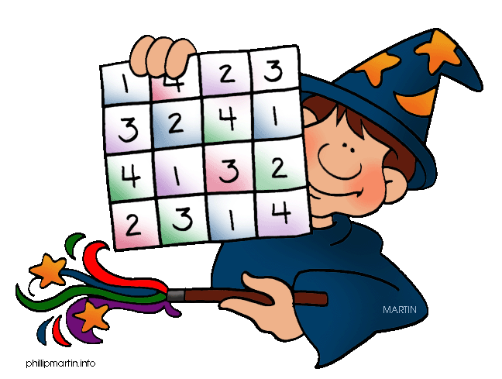  - Reading Numbers to 30 Game  - 1-30 Game
Spellodrome  Writing | List 15  Practice 5 words from list 15 in cursive handwriting (you do not need to bring this into school)
Reading | Recommended daily reading time:  Year 1 15-20 minutes
Home Learning Project

Greek | Please go to Greek Class Blog for Greek Home Learning  Greek Class - St Cyprian's Greek Orthodox Primary Academy

