YEAR 1 HOME LEARNING
Date Set | 18.12.2015
Date Due | 04.01.2016
Mathletics | 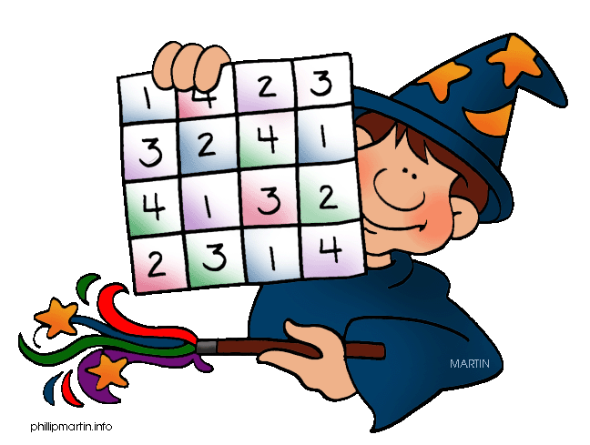  Number and Place Value to 50  Activities: Before, After and Between to 20
Spellodrome  Writing | List 10  Practice 5 words from list 10 in cursive handwriting (you do not need to bring this into school)
Reading | Recommended daily reading time:  Year 1 15-20 minutes
Home Learning Project

Greek | Please go to Greek Class Blog for Greek Home Learning  Greek Class - St Cyprian's Greek Orthodox Primary Academy

