YEAR 2 HOME LEARNING
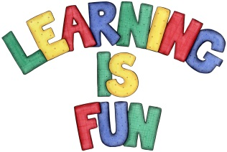
Date Set | Friday 4th December 2015
Date Due | Friday 11th December 2015
Mathletics | 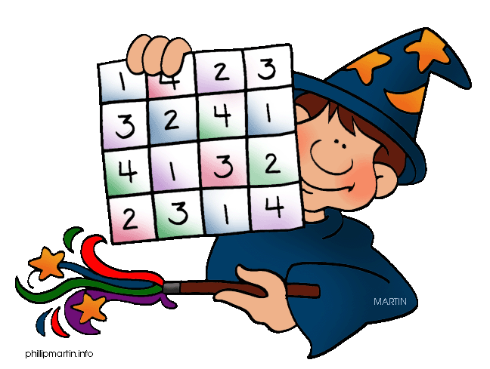  We would like the children to complete the missing number and sort the shapes activities on their Mathletics profile. For example they will be given missing number sentences involving addition and subtraction where they need to identify what the missing number is. They will also be given different shapes that they need to sort into different categories e.g. put all the circles in the hoop.
Spellodrome  Writing | We would like the children to learn words that end with ‘y’  such as try, cry, fly, reply, July etc.  The children will also be  completing an activity where they need to identify the  correct homophones to complete a variety of sentences. For example I want to go to the park.
Reading | Recommended daily reading time:  KS1 15-20 minutes  KS2 40 minutes
Greek | Please go to Greek Class Blog for Greek Home Learning  Greek Class - St Cyprian's Greek Orthodox Primary Academy

