YEAR 1 HOME LEARNING
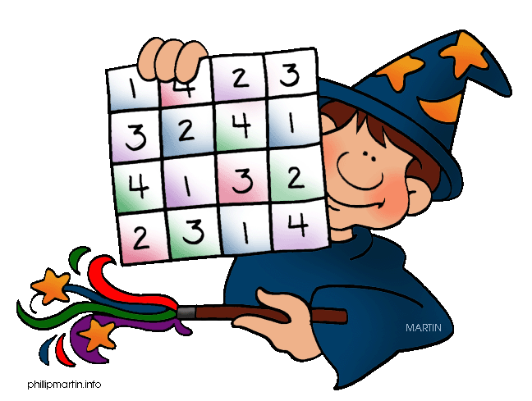
Date Set | 8/1/16
Date Due | Mathletics and Spellodrome 27/1/15  Pink Book: 29/1/15
Mathletics | There are some activities relating to this week’s learning on translation and rotation, and some other activities to finish off.
Spellodrome  Writing | A new word list has been added to spellodrome. These words are in the word list n – p.  Your writing task this week is to base a story on your favourite character from a book. It is up to you which character you choose but you must make up a new story and not retell an existing one.
Reading | Recommended daily reading time:  KS1 15-20 minutes  KS2 40 minutes
Home Learning Project | Date Set: 22/1/16  Date Due: Pink Book: 27/1/16  Mathletics and Spellodrome: 29/1/16
Greek | Please go to Greek Class Blog for Greek Home Learning  Greek Class - St Cyprian's Greek Orthodox Primary Academy

