YEAR 1 HOME LEARNING
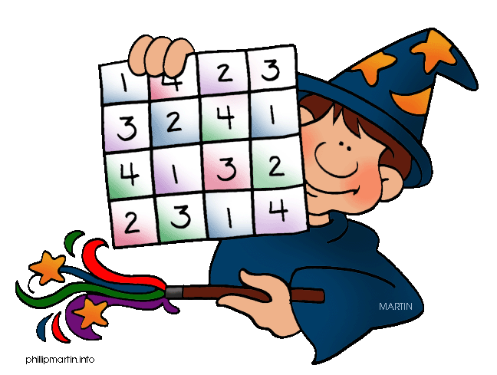
Date Set | 8/1/16
Date Due | Mathletics and Spellodrome 16/1/15  Pink Book: 13/1/15
Mathletics | There are some activities relating to place number to completed on mathletics, and some other activities to finish off.
Spellodrome  Writing | A new word list has been added to spellodrome. The words are all homophones. Please ensure you learn the MEANINGs as well as the spelling of each word.  Your writing task this week is to write a story that starts:  She was sure this is where he had disappeared….
Reading | Recommended daily reading time:  KS1 15-20 minutes  KS2 40 minutes
Home Learning Project | Date Set: 8/1/16  Date Due: Pink Book: 13/1/16  Mathletics and Spellodrome: 15/1/16
Greek | Please go to Greek Class Blog for Greek Home Learning  Greek Class - St Cyprian's Greek Orthodox Primary Academy

