YEAR 1 HOME LEARNING
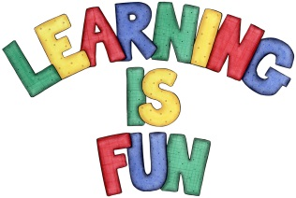
Date Set | 8.1.16
Date Due | 15.1.16
Mathletics | 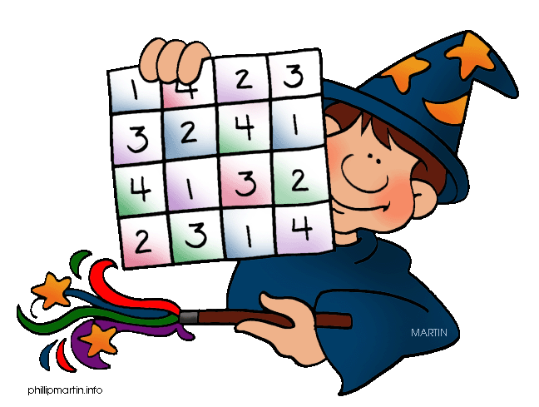  Multiplication and Division  Groups of 2  Children need to learn their 2x tables off by heart  Children to learn number bonds  to 20 (addition pairs of numbers to 20)
Spellodrome  Writing | List 5  Practice 5 words from list 5 in cursive handwriting (you do not need to bring this into school)
Reading | Recommended daily reading time:  Year 1 15-20 minutes
Home Learning Project | Date Set: 8.1.16 Date Due: 15.2.16  Choose either Princess Diana or Nelson Mandela and create a poster about them: Include research about them, pictures and why they were influential.
Greek | Please go to Greek Class Blog for Greek Home Learning  Greek Class - St Cyprian's Greek Orthodox Primary Academy

