YEAR 1 HOME LEARNING
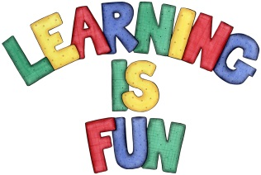
Date Set | 22.1.16
Date Due | 29.1.16
Mathletics | 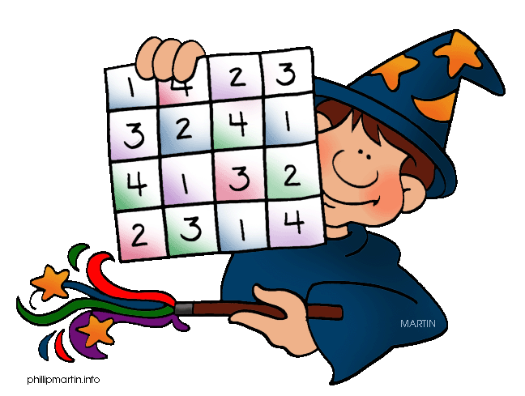  Multiplication and Division  Share the Treasure  Children need to learn their 2x tables off by heart  Children to learn number bonds  to 20 (addition pairs of numbers to 20)
Spellodrome  Writing | List 36  Practice 5 words from list 36 in cursive handwriting (you do not need to bring this into school)
Reading | Recommended daily reading time:  Year 1 15-20 minutes
Home Learning Project | Date Set: 8.1.16 Date Due: 15.2.16  Choose either Princess Diana or Nelson Mandela and create a poster about them: Include research about them, pictures and why they were influential.
Greek | Please go to Greek Class Blog for Greek Home Learning  Greek Class - St Cyprian's Greek Orthodox Primary Academy

