YEAR 2 HOME LEARNING
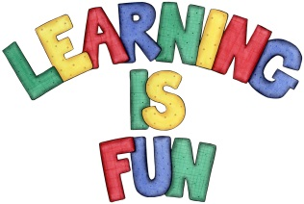
Date Set | Friday 15th January 2016
Date Due | Friday 22nd January 2016
Mathletics | 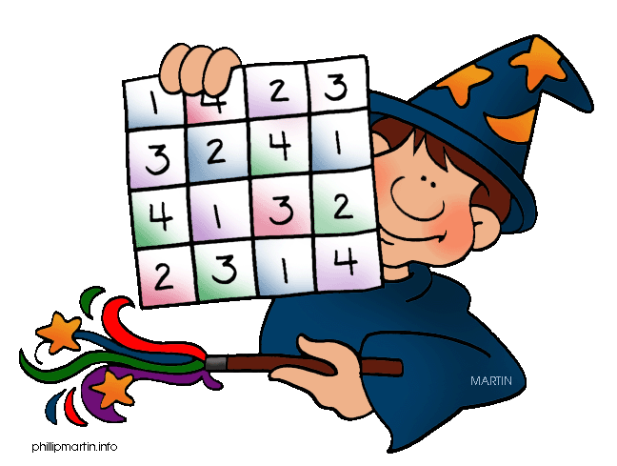  We would like the children to complete the ‘Reparation Two Digit Numbers’ activity on their Mathletics profile. For example they will be given different 2 digit numbers that they need to make up using tens and ones cubes. They will also be completing the ‘Tell The Time’ activity where they need to set the hands on the clock to the correct times either half past, quarter past or quarter to.
Spellodrome  Writing | We would like the children to learn words that end with ‘ing’  such as replying, trying, crying, frying etc.  The children will also be  completing an activity where they need to spell the correct word in the past tense. For example the baby pulled my hair.
Reading | Recommended daily reading time:  KS1 15-20 minutes  KS2 40 minutes
Greek | Please go to Greek Class Blog for Greek Home Learning  Greek Class - St Cyprian's Greek Orthodox Primary Academy

