YEAR 2 HOME LEARNING
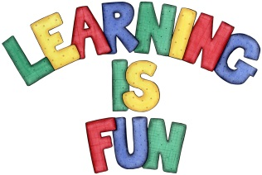
Date Set | Friday 22nd January 2016
Date Due | Friday 29th January 2016
Mathletics | 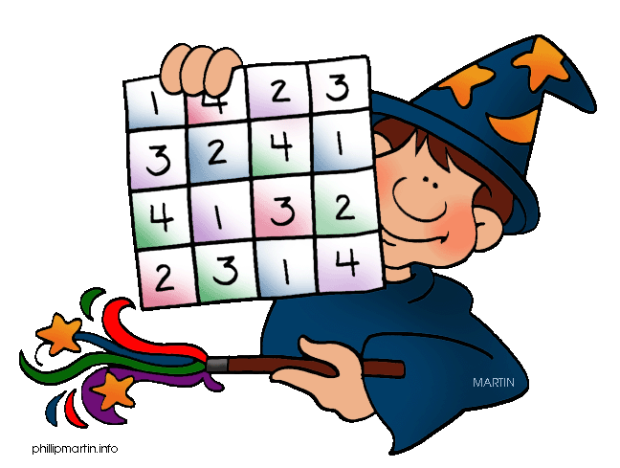  We would like the children to complete the ‘count by 2s, 5s and 10s’ activity on their Mathletics profile. For example they will be given a number line with missing numbers that they need to put in the correct place. They will also be completing the ‘Temperature’ activity where they need to read and write the temperature shown on the thermomete.
Spellodrome  Writing | We would like the children to learn words that end with –er  to root words ending in consonant-letter-y  such as copier, carrier, drier, happier, busier etc.  The children will also be  completing an activity where they need to identify the sentence with the correct punctuation in it.
Reading | Recommended daily reading time:  KS1 15-20 minutes  KS2 40 minutes
Greek | Please go to Greek Class Blog for Greek Home Learning  Greek Class - St Cyprian's Greek Orthodox Primary Academy

