YEAR 2 HOME LEARNING
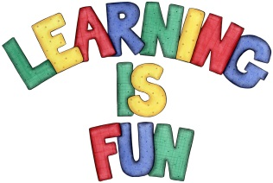
Date Set | Friday 8th January 2016
Date Due | Friday 15th January 2016
Mathletics | 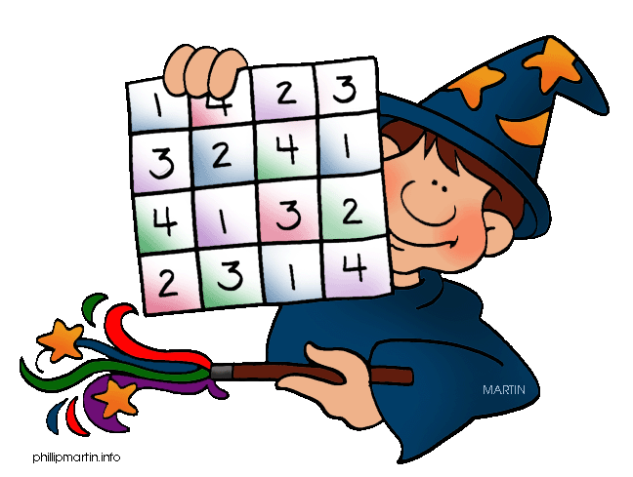  We would like the children to complete the ‘How Long Is It?’ activity on their Mathletics profile. For example they will be given different objects that they need to measure accurately using a ruler measured in centimetres.
Spellodrome  Writing | We would like the children to learn words that end with ‘ed’  such as tried, cried, lied, fried, replied, carried etc.  The children will also be  completing an activity where they need to identify the  correct conjunction to complete a variety of sentences. For example we did not go out because we were tired.
Reading | Recommended daily reading time:  KS1 15-20 minutes  KS2 40 minutes
Greek | Please go to Greek Class Blog for Greek Home Learning  Greek Class - St Cyprian's Greek Orthodox Primary Academy

