YEAR 1 HOME LEARNING
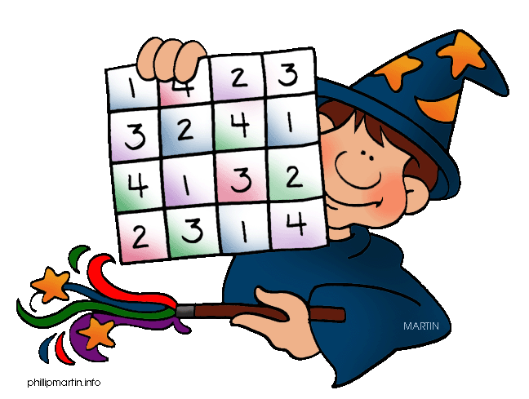
Date Set | 19/2/16
Date Due | Mathletics and Spellodrome 29/2/16  Pink Book: 29/2/16
Mathletics | There is a new assessment, and some activities relating to pie charts.
Spellodrome  Writing | A new word list has been added to spellodrome. These words are in the word list s-z. There is also an assessment to be completed.  Your task this week is to write a mystery story. You are with your friend in London and they go missing. What has happened? Where did they go? How will you solve this?
Reading | Recommended daily reading time:  KS1 15-20 minutes  KS2 40 minutes
Home Learning Project | Date Set: 19/2/16  Date Due: Pink Book: 29/2/16  Mathletics and Spellodrome: 29/2/16
Greek | Please go to Greek Class Blog for Greek Home Learning  Greek Class - St Cyprian's Greek Orthodox Primary Academy

