YEAR 1 HOME LEARNING
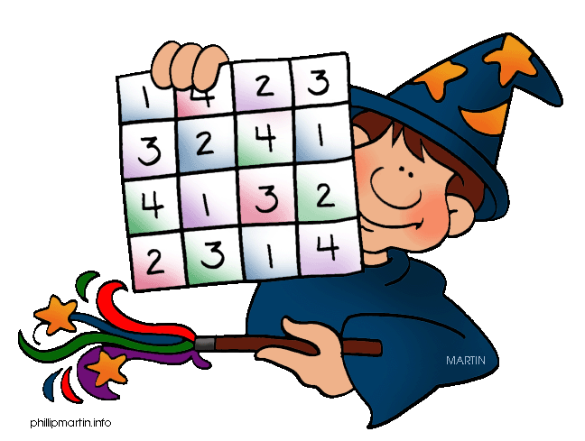
Date Set | 5/2/16
Date Due | Mathletics and Spellodrome 12/2/16  Pink Book: 10/2/16
Mathletics | There are some activities relating worded problems around BODMAS/BIDMAS and the order of operations, and some problems around fractions
Spellodrome  Writing | A new word list has been added to spellodrome. These words are in the word list q-r.  Your writing task this week is to write a story starting: It happened so quickly I had no time to think, only react.
Reading | Recommended daily reading time:  KS1 15-20 minutes  KS2 40 minutes
Home Learning Project | Date Set: 5/2/16  Date Due: Pink Book: 10/2/16  Mathletics and Spellodrome: 12/2/16
Greek | Please go to Greek Class Blog for Greek Home Learning  Greek Class - St Cyprian's Greek Orthodox Primary Academy

