YEAR 1 HOME LEARNING
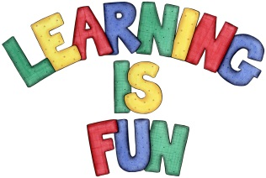
Date Set | 2.2.16
Date Due | 12.216
Mathletics | 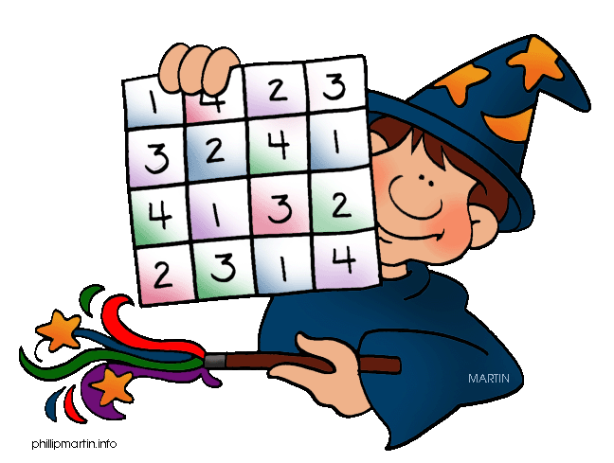  Multiplication and Division  Multiplication Arrays  Children need to learn their 2x, 5 and 10x tables off  by heart  Children to learn number bonds  to 20 (addition pairs of numbers to 20)
Spellodrome  Writing | List 9  Practice 5 words from list 9 in cursive handwriting (you do not need to bring this into school)
Reading | Recommended daily reading time:  Year 1 15-20 minutes
Home Learning Project | Date Set: 8.1.16 Date Due: 15.2.16  Choose either Princess Diana or Nelson Mandela and create a poster about them: Include research about them, pictures and why they were influential.
Greek | Please go to Greek Class Blog for Greek Home Learning  Greek Class - St Cyprian's Greek Orthodox Primary Academy

