YEAR 1 HOME LEARNING
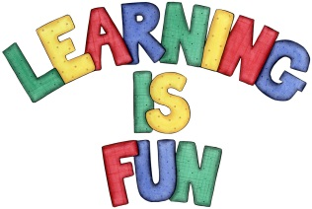
Date Set | 19.2.16
Date Due | 29.2.16
Mathletics | 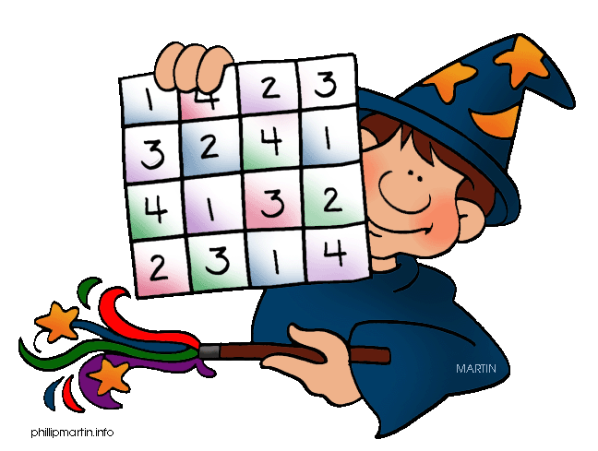  Number and Place Value to 100  Descending Order  Children need to learn their 2x, 5 and 10x tables off  by heart  Children to learn number bonds  to 50-100 (addition pairs of numbers to 50-100)
Spellodrome  Writing | List 16  Practice 5 words from list 16 in cursive handwriting (you do not need to bring this into school)
Reading | Recommended daily reading time:  Year 1 15-20 minutes
Home Learning Project | NA
Greek | Please go to Greek Class Blog for Greek Home Learning  Greek Class - St Cyprian's Greek Orthodox Primary Academy

