YEAR 2 HOME LEARNING
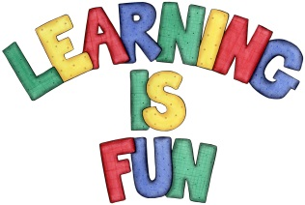
Date Set | Friday 19th February 2016
Date Due | Friday 4th March 2016
Mathletics | 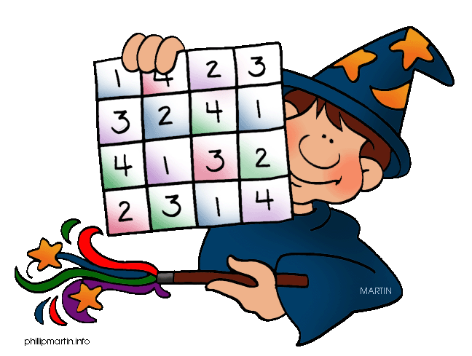  We would like the children to complete the ‘making big numbers count’ activity on their Mathletics profile. For example they will be given a 2 digit number and some blocks and rods. The children then need to drag the correct number of blocks and rods on to the mat to make the number given. They will also be completing the ‘balancing act’ activity where they need to click on the correct object that would equal out the balance scale.
Spellodrome  Writing | We would like the children to learn words that end with –ey  such as key, donkey, monkey, chimney, etc.  The children will also be  completing an activity where they need to identify the correct sentence with the correct contraction in it e.g. That’s an excellent picture!
Reading | Recommended daily reading time:  KS1 15-20 minutes  KS2 40 minutes
Greek | Please go to Greek Class Blog for Greek Home Learning  Greek Class - St Cyprian's Greek Orthodox Primary Academy

