YEAR 1 HOME LEARNING
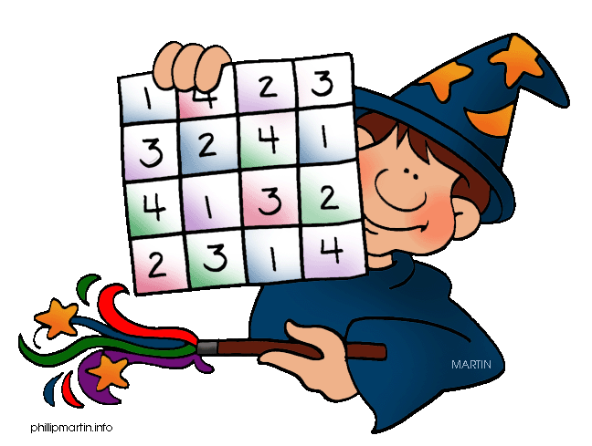
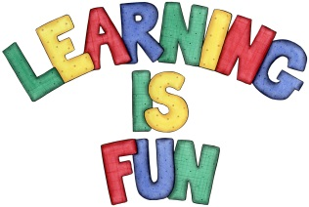
Date Set | 11/3/16
Date Due | Mathletics and Spellodrome 25/3/16  Pink Book: 23/3/16
Mathletics | There are some activities relating to our learning about circles.
Spellodrome  Writing | Please continue to practise the words in your word lists.  This week in literacy we have been writing science fiction stories. Your writing task this week is to write a story about a UFO landing in the playground.
Reading | Recommended daily reading time:  KS1 15-20 minutes  KS2 40 minutes
Home Learning Project | Date Set: 11/3/16  Date Due: Pink Book: 23/3/16  Mathletics and Spellodrome 25/3/16
Greek | Please go to Greek Class Blog for Greek Home Learning  Greek Class - St Cyprian's Greek Orthodox Primary Academy

