YEAR 1 HOME LEARNING
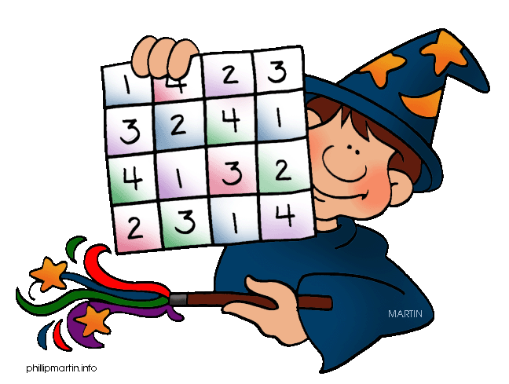
Date Set | 18/3/16
Date Due | Mathletics and Spellodrome 25/3/16  Pink Book: 23/3/16
Mathletics | There are some activities relating to units of measure.
Spellodrome  Writing | Please continue to practise the words in your word lists.  Your writing task this week is to write a horror story. You can set it wherever you like. Remember to be as descriptive as you can.
Reading | Recommended daily reading time:  KS1 15-20 minutes  KS2 40 minutes
Home Learning Project | Date Set: 18/3/16  Date Due: Pink Book: 23/3/16  Mathletics and Spellodrome 25/3/16
Greek | Please go to Greek Class Blog for Greek Home Learning  Greek Class - St Cyprian's Greek Orthodox Primary Academy

