YEAR 1 HOME LEARNING
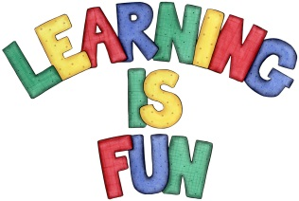
Date Set | 04.03.16
Date Due | 11.03.16
Mathletics | 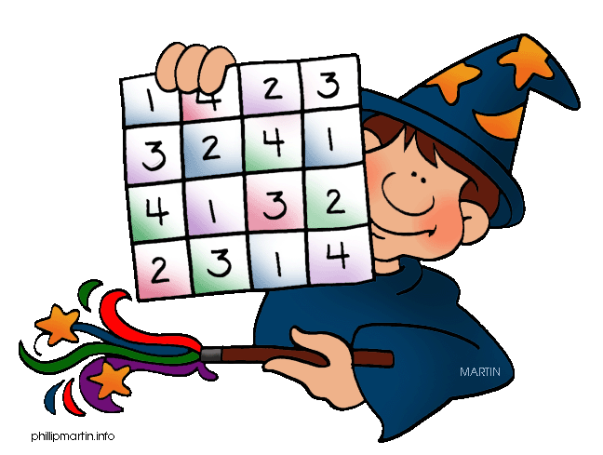  Multiplication and Division  Model Multiplication to 5x5  Children need to learn their 5x tables off by heart  Children to learn number bonds  to 20 (addition pairs of numbers to 20)
Spellodrome  Writing | List 29  Practice 5 words from list 5 in cursive handwriting (you do not need to bring this into school)
Reading | Recommended daily reading time:  Year 1 15-20 minutes
Home Learning Project | Date Set: 04.03.16 Date Due: 15.04.16  Make a book about different plants and animals you have seen in the gardens or parks.
Greek | Please go to Greek Class Blog for Greek Home Learning  Greek Class - St Cyprian's Greek Orthodox Primary Academy

