YEAR 1 HOME LEARNING
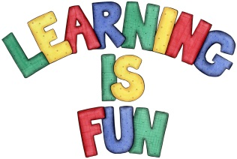
Date Set | 24.03.16
Date Due | 1.4.16
Mathletics | 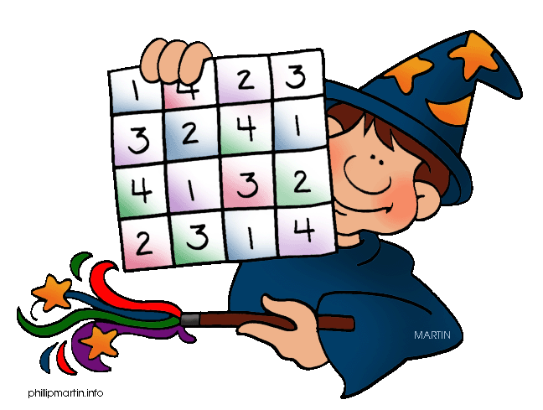  Number and Place Value to 100  - Making Big Numbers Count  Children need to learn their 2,5, 10x tables off by  heart  Children to learn number bonds  to 20 and 50
Spellodrome  Writing | List 13  Practice 5 words from list 5 in cursive handwriting (you do not need to bring this into school)
Reading | Recommended daily reading time:  Year 1 15-20 minutes
Home Learning Project | Date Set: 04.03.16 Date Due: 15.04.16  Make a book about different plants and animals you have seen in the gardens or parks.
Greek | Please go to Greek Class Blog for Greek Home Learning  Greek Class - St Cyprian's Greek Orthodox Primary Academy

