YEAR 2 HOME LEARNING
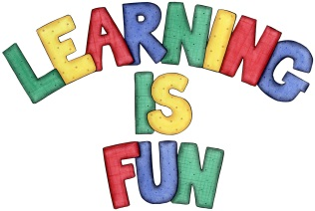
Date Set | Friday 11th March 2016
Date Due | Friday 18th March 2016
Mathletics | We would like the children to complete the ‘place value 1’ activity on their Mathletics profile. For example they will be shown an abacus with beads on the tens and ones rods. The children then need to write the number that is represented e.g. if there were 8 beads on the tens column and 7 beads on the ones column the answer would be 87. They will also be completing the ‘adding 2 digit numbers’ activity where they will be given different addition problems  which they need to solve and make the answer using the tens  and one e.g. you start with 55 blocks. You add 6 more. How  many blocks do you have now?
Spellodrome  Writing | We would like the children to learn words that have the o  sound such as other, mother, grandmother, another, etc.  The children will also be completing an apostrophe activity. They will be given different sentences where the apostrophe is missing and have to click on the word that shows the correct apostrophe. E.g. May I sit on Sue_s_ chair_? The answer would be Sue’s.
Reading | Recommended daily reading time:  KS1 15-20 minutes  KS2 40 minutes
Greek | Please go to Greek Class Blog for Greek Home Learning  Greek Class - St Cyprian's Greek Orthodox Primary Academy
