YEAR 2 HOME LEARNING
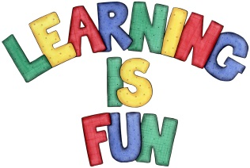
Date Set | Friday 4th March 2016
Date Due | Friday 11th March 2016
Mathletics | We would like the children to complete the ‘reparation to subtract’ activity on their Mathletics profile. For example they will be given 2 two digit numbers that they need to subtract. The children then need to click on the number to split into tens and units to support them with their taking away in order to solve the calculation. They will also be completing the ‘complete the pattern’ activity where they need to click on the correct shape that will complete the pattern.
Spellodrome  Writing | We would like the children to learn words that end with –ey  such as key, donkey, monkey, chimney, etc.  The children will also be completing a question mark and exclamation mark activity. They will be given different sentences and have to click on the sentence that shows either the question mark or the exclamation mark in the correct place. E.g. Where did the ball go? Or “Look out!” the little boy yelled.
Reading | Recommended daily reading time:  KS1 15-20 minutes  KS2 40 minutes
Greek | Please go to Greek Class Blog for Greek Home Learning  Greek Class - St Cyprian's Greek Orthodox Primary Academy
