YEAR 1 HOME LEARNING
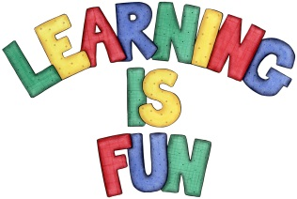
Date Set | 22.4.16
Date Due | 13.5.16
Mathletics | 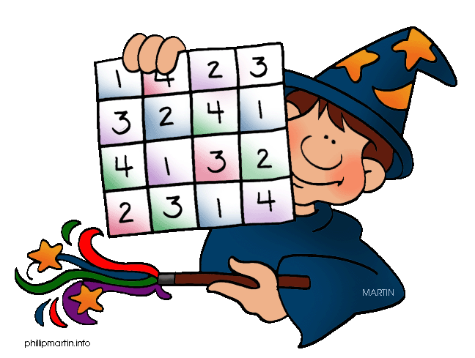  Length, Mass and Volume  - Everyday Length  Children need to learn their 2,5, 10x tables off by  heart  Children to learn number bonds  to 20 and 50
Spellodrome  Writing | List 24  Practice 5 words from list 24 in cursive handwriting (you do not need to bring this into school)
Reading | Recommended daily reading time:  Year 1 15-20 minutes
Home Learning Project | Date Set: Date Due:
Greek | Please go to Greek Class Blog for Greek Home Learning  Greek Class - St Cyprian's Greek Orthodox Primary Academy

