YEAR 1 HOME LEARNING
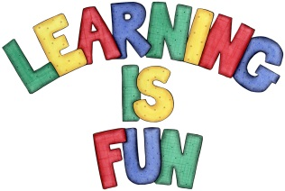
Date Set | 3.6.15
Date Due | 10.6.15
Mathletics | Length, Mass and Volume  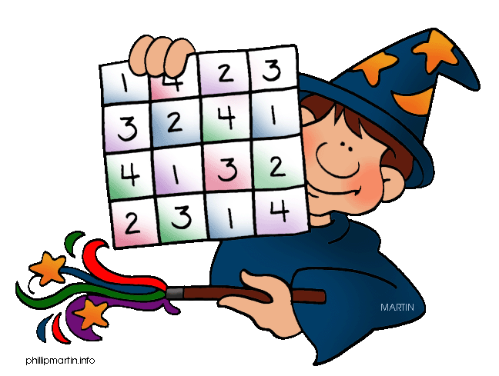  Filling Fast  Children need to learn their 2x, 5x and 10x tables off by heart  Children to learn number bonds  to 50 (addition pairs of numbers to 50)
Spellodrome  Writing | List 27  Practice 5 words from list 5 in cursive handwriting (you do not need to bring this into school)
Reading | Recommended daily reading time:  Year 1 15-20 minutes
Home Learning Project | Date Set: 13.05.16 Date Due: 10.06.16  Make a poster about a famous Chinese Olympian. Which sport are they famous for?
Greek | Please go to Greek Class Blog for Greek Home Learning  Greek Class - St Cyprian's Greek Orthodox Primary Academy

