YEAR 1 HOME LEARNING
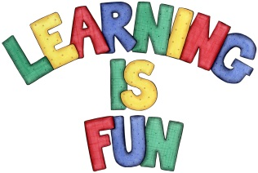
Date Set | 13.05.16
Date Due | 20.05.16
Mathletics | 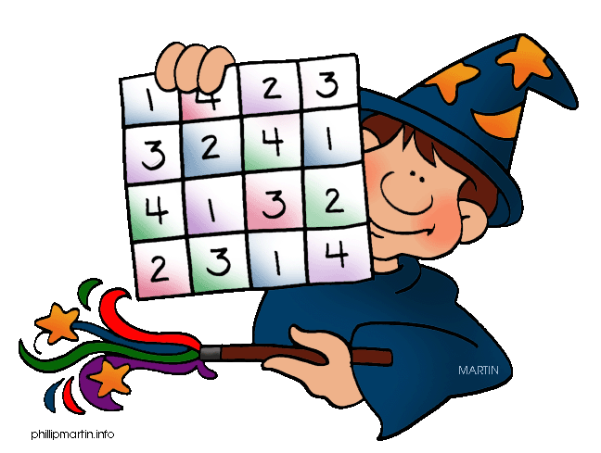  Length, Mass and Volume  Everyday Mass  Children need to learn their 5x tables off by heart  Children to learn number bonds  to 20 (addition pairs of numbers to 20)
Spellodrome  Writing | List 17  Practice 5 words from list 5 in cursive handwriting (you do not need to bring this into school)
Reading | Recommended daily reading time:  Year 1 15-20 minutes
Home Learning Project | Date Set: 13.05.16 Date Due: 10.06.16  Make a poster about a famous Chinese Olympian. Which sport are they famous for?
Greek | Please go to Greek Class Blog for Greek Home Learning  Greek Class - St Cyprian's Greek Orthodox Primary Academy

