YEAR 1 HOME LEARNING
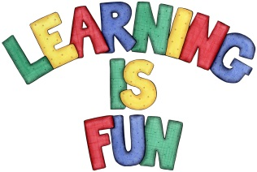
Date Set | 10.06.16
Date Due | 24.06.16
Mathletics | 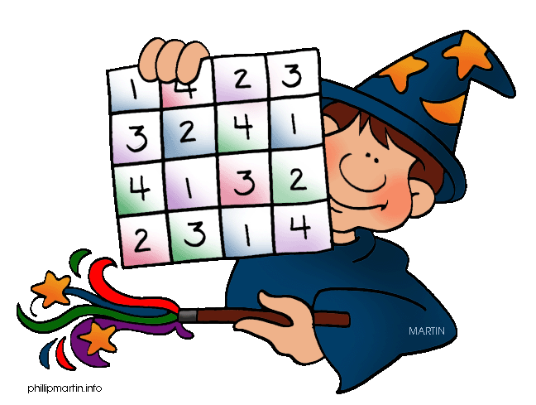  Comparing Numbers  Greater or Less to 100  Children need to learn their 5x tables off by heart  Children to learn number bonds  to 20 (addition pairs of numbers to 20)
Spellodrome  Writing | Lists 11 and 12  Practice 5 words from list 5 in cursive handwriting (you do not need to bring this into school)
Reading | Recommended daily reading time:  Year 1 15-20 minutes
Home Learning Project | Date Set: 13.05.16 Date Due: 10.06.16  Make a poster about a famous Chinese Olympian. Which sport are they famous for?
Greek | Please go to Greek Class Blog for Greek Home Learning  Greek Class - St Cyprian's Greek Orthodox Primary Academy

