YEAR 1 HOME LEARNING
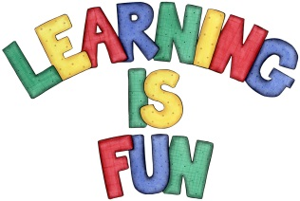
Date Set | 01.07.16
Date Due | 15.07.16
Mathletics | 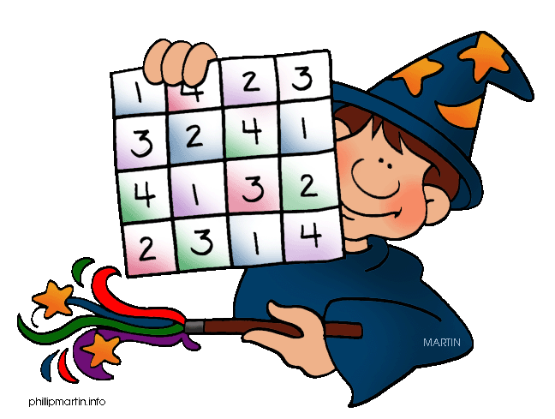  Time and Money  Hour Time  Tell time to the Half Hour  Children need to learn their 2x, 5x and 10x tables off by heart  Children to learn number bonds  to 50 (addition pairs of numbers to 50)
Spellodrome  Writing | Lists 28 and 37  Practice 5 words from each list in cursive handwriting (you do not need to bring this into school)
Reading | Recommended daily reading time:  Year 1 15-20 minutes
Home Learning Project | Date Set: 24.6.16 Date Due: 15.7.16  Create a Fact File about your chosen animal. Your Fact File needs to include: A drawing or a photograph of the animal, Description of the Animal, Diet, Habitat and some interesting Fun Facts
Greek | Please go to Greek Class Blog for Greek Home Learning  Greek Class - St Cyprian's Greek Orthodox Primary Academy

