YEAR 3 HOME LEARNING
Date Set | 12-9-2016
Date Due | 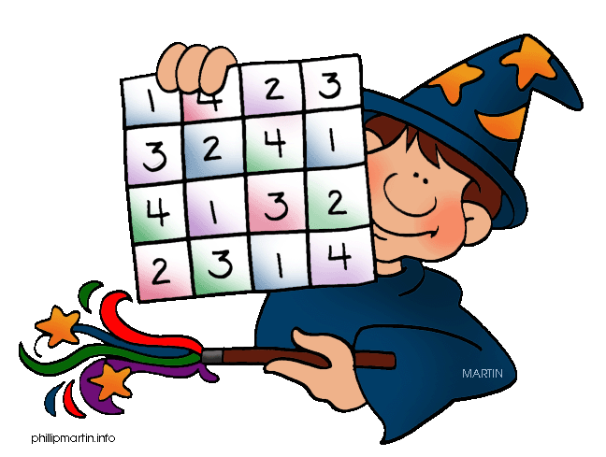  19-9-2016
Mathletics | Practise number place value
Spellodrome  Writing | Practise spelling in Spellodrome  Superstar, supermarket, superficial, supernatural,  Superhuman, supervise, superstitious, superglue  - Write five sentences using adjectives.  - Write five sentences using conjunctions
Reading | Recommended daily reading time:  KS2 40 minutes
Home Learning Project  (our project for the next few weeks is about Ancient Greece) | Date Set: 12-9 Date Due: 15-10  Create your own Ancient Greek front page of a newspaper.  - Give your newspaper a good name  - Think of headlines  - Include pictures and a map  - Think of events that happened in Ancient Greece (Olympics, Oracles, Wars, Inventions)
Please go to Greek Class Blog for Greek Home Learning

Greek Class - St Cyprian's Greek Orthodox Primary Academy

