[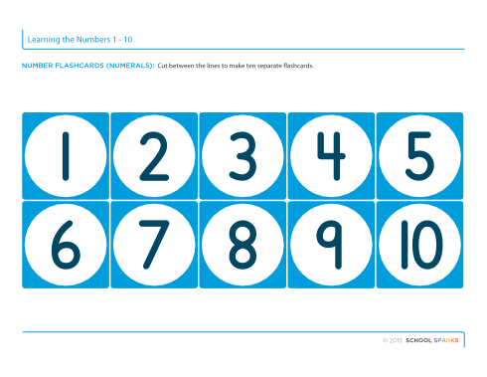](http://www.google.co.uk/url?sa=i&rct=j&q=&esrc=s&source=images&cd=&cad=rja&uact=8&ved=0ahUKEwiu3NC0zKfPAhUB1hQKHeomAKIQjRwIBw&url=http://www.schoolsparks.com/kindergarten-worksheets/category/tracing-numbers&bvm=bv.133700528,d.ZGg&psig=AFQjCNHrx8bGPDrJI4Y5DAmwuV3mx4Zotg&ust=1474792475046266)