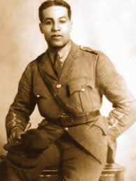
Black History Month Home Learning Project
As part of our inclusion week we are celebrating Black History Month. We are also coming up to Remembrance Day, so we have decided to combine our
learning on these two important events.

Your task: For your home learning we would like you to find out about Walter Tull, a WW1 hero with an incredible and inspiring story. You will need to present your research so that it can be shared with others. You can do this in a number of ways for example, a poster, diary, information booklet, a model or a PowerPoint presentation.
If you choose to make a PowerPoint presentation could you please either print it off at home, or send it into school on a memory stick or disk. Once the PowerPoint has been viewed by the teacher the memory stick or disk will be returned to you. Please remember to write your name clearly on your home learning.
Your home learning project must tell us:
- Where Walter Tull grew up and who his family were
- What Walter Tull did as a living
- What happened when the First World War broke out
- Why Walter Tull is so important in the history of the army
We hope you enjoy finding out more. Here are some websites to support you with your home learning:
http://www.actionforchildren.org.uk/news/archive/2014/september/action-for-children-old-boy-walter-tull-honoured-with-5-coin
http://www.bbc.co.uk/schools/0/ww1/25403975

