YEAR 2 HOME LEARNING
Date Set | Friday 14th October 2016
Date Due | Friday 21st October 2016
Mathletics | 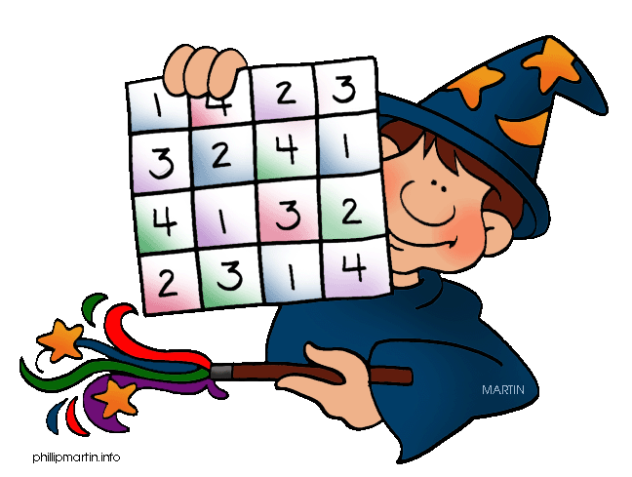  We would like the children to complete the ‘adding 2 digit numbers’ activity on their Mathletics profile. For example they will be given different calculations and using the rods and ones they need to solve them. We would also like the children to complete the ‘all about twenty’ activity where they need to solve addition and subtraction calculations involving 20.
Spellodrome  Writing | We would like the children to learn words that end with  ‘dge’ such as badge, ledge, wedge, hedge, lodge, dodge etc.  The children will also be  completing an activity where they need to identify the  sentence with the correct punctuation. For example The test was on Friday. I studied hard for it and I hope I did well.
Reading | Recommended daily reading time:  KS1 15-20 minutes  KS2 40 minutes
Greek | Please go to Greek Class Blog for Greek Home Learning  Greek Class - St Cyprian's Greek Orthodox Primary Academy

