YEAR 2 HOME LEARNING
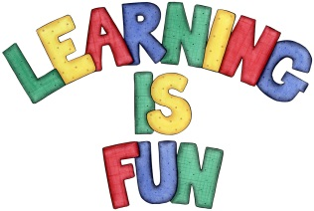
Date Set | Friday 21st October 2016
Date Due | Friday 4th November 2016
Mathletics | 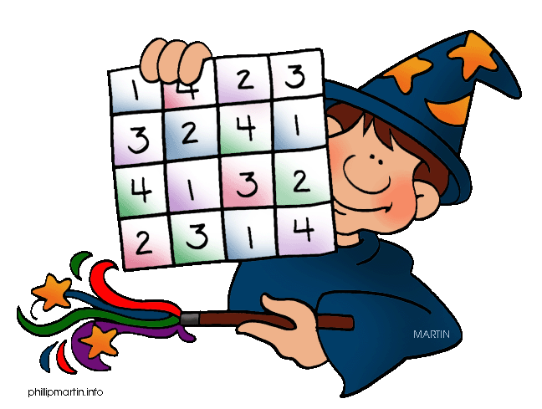  We would like the children to complete the ‘how full’ activity on their Mathletics profile. For example they will be given different objects and will have to identify how full the different objects are. We would also like the children to complete the ‘using litre’ activity where they need to identify how full the container is in either litres or millilitres.
Spellodrome  Writing | We would like the children to learn words that end with  ‘ge’ such as age, charge, village, page etc.  The children will also be  completing an activity where they need to identify the  sentence with the correct punctuation. For example “Do you have a coin I could borrow?” asked Jai.
Reading | Recommended daily reading time:  KS1 15-20 minutes  KS2 40 minutes
Greek | Please go to Greek Class Blog for Greek Home Learning  Greek Class - St Cyprian's Greek Orthodox Primary Academy

