YEAR 2 HOME LEARNING
Date Set | Friday 11th November 2016
Date Due | Friday 18th November 2016
Mathletics | 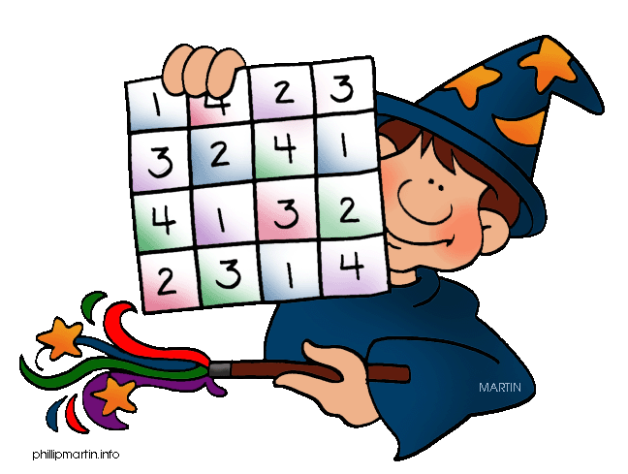  We would like the children to complete the ‘shade the fraction’, ‘part whole rods’ and ‘who has which coins’ activities on their Mathletics profile. They will be given shapes on which they need to colour in the given fraction. They will then have to identify the fraction of a rod against the whole rod.
Spellodrome  Writing | We would like the children to learn words that have the ‘s’ sound spelt with a c such as race, face, rice, ice, cell, city etc.  The children will also be  completing an activity where they need to identify the  correct place where the comma needs to go in a sentence.  For example – Megan, Kate and Ben went to the park.
Reading | Recommended daily reading time:  KS1 15-20 minutes  KS2 40 minutes
Greek | Please go to Greek Class Blog for Greek Home Learning  Greek Class - St Cyprian's Greek Orthodox Primary Academy

